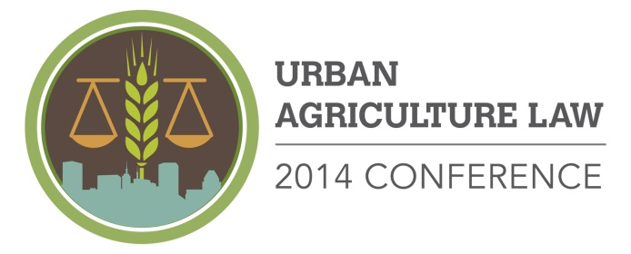

Call for Papers & Presentations

Application Cover Sheet

Community Law Center, Inc. and University of Maryland Francis King Carey School of Law are hosting the 2014 Urban Agriculture Law Conference on September 19, 2014 in Baltimore to share information and best practices in urban agriculture laws, policies, and practices across the country. We are currently accepting proposals for papers and presentations through June 15, 2014.

Name: Organization:

Address:

City: State: Zip: Phone:

Email:

Co-panelist(s)/Co-Author(s):

Title of Presentation, Paper or Workshop:

Please indicate if your proposal is for:
- A Case Study Panel - We invite panel discussions by attorneys and clients with other partners (nonprofit, government, or private sector). The panel may be organized and submitted as a group by a panel coordinator, or an individual may submit a particular viewpoint to be considered for part of a panel organized by the Conference Committee.

- A Legal Academic and Research Presentations - We invite papers and presentations of research about issues concerning urban agriculture law and/or policy. Accepted papers will be considered for publication by the legal journals of the University of Maryland Francis King Carey School of Law.

- A Legal Workshop - We invite workshop sessions designed to teach a diverse audience about legal issues of concern to urban farmers, municipalities, and to lawyers providing representation to urban farmers.

Target Audience?
Please indicate your target audience (check all that apply):

- Lawyers
- Law Professors
- Graduate Students

- Urban Farmers
- Community Leaders
- Health Professionals

- Nonprofits
- Community Development Corporations
- Government Employees
- Elected Officials

Proposal Content:
Topics – The Conference Committee seeks proposals on topics relevant to urban agriculture and the law. Please indicate which topic(s) are covered by your proposal:

- Reviving Vacant Land, Revitalizing Cities
- Getting Started: Choice of Legal Entity, Accessing Water, Land, and Other Resources
- Labor, Licensing, and Other Rules of Food Production & Sales
- Making the Connections Between Urban Agriculture, Health, and Environmental Law and Policy
- Other:

Content – Selections will be made based upon desired topics, flow of content, and educational value. Please attach a 1-2 page description of your paper or presentation.

All applications must contain this application cover sheet and a 1-2 page description of the proposed paper or presentation.

Submit complete applications to: 2014UrbanAgricultureLawConference@communitylaw.org

