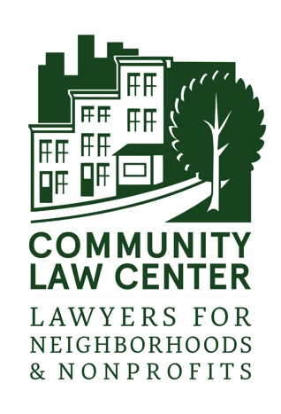
THANK YOU FOR DONATING YOUR SERVICES THROUGH COMMUNITY LAW CENTER’S PRO BONO PROGRAM!

Your assistance with filling out this form allows us to continue operating the Pro Bono Program. These reports also provide an opportunity for feedback, updates, and reflection. If you have time to elaborate on your progress or problems encountered, please include that information as well. We appreciate any feedback, and would like the chance to celebrate your accomplishments with your clients. Please make sure to forward this to any attorneys who worked with you and ask them to complete a form as well.

Volunteer Attorney Hours Report

Contact Information
Attorney Name: |  |  |  |  |  | Date Form Completed:
Firm:
- This report covers the July 1 – December 31 reporting period

- This report covers the January 1 – June 30 reporting period

Case Information
Client | Approx. date case was opened | Approx. date case was closed | Total number of hours expended during reporting period | Billing rate | Status - please enter letter below for all that apply.  a. Case is ongoing  b. Case is closed  c. Client unresponsive  d. Case is on appeal.  e. I would like CLC to assign a new attorney. |  | Any milestones reached? (please describe)
 |  |  |  | $
 |  |  |  | $
 |  |  |  | $
 |  |  |  | $
 |  |  |  | $
Feedback
Have you received adequate assistance from Community Law Center staff throughout your case(s)? (Please select one and comment below.)
❑ Yes ❑ I would like assistance with… ❑ No, please explain ❑ In the future, I would like assistance with:

Do you have any suggestions for how the Community Law Center staff could have done a better job in assisting you or your client in handling Pro Bono Program cases in general?

The Community Law Center always needs new volunteers! Please provide the name and contact information of any attorneys you think may be interested in working with the Pro Bono Program:

Please return this form to
meganw@communitylaw.org or 410.366.7763 (fax).

Questions or comments? Megan Wakefield at meganw@communitylaw.org or 410.366.0922 x 118.

