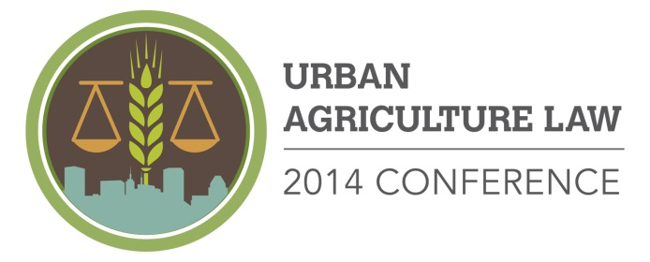

Scholarship Form

Community Law Center, Inc. and University of Maryland Francis King Carey School of Law are hosting the 2014 Urban Agriculture Law Conference on September 19, 2014 in Baltimore to share information and best practices in urban agriculture laws, policies, and practices across the country.

We do not want the cost of registration to deter you from attending. If you would like to attend, but are in need of financial assistance, please complete this form and return it by August 15, 2014. A limited amount of scholarship funds are available and will be awarded at the full discretion of the Conference Committee.

Name(s):

Organization:

Address:

City: State: Zip: Phone:

Email:

Please indicate your registration choice(s):

Qty. | Rate* | Pass
 | $150 early bird rate (ends 8/15/2014) | Full Conference (Includes free parking in the Grand Garage, all conference sessions, breakfast, bus tour, lunch, and film screening with networking reception)
 | $25 | Breakfast Only (7:30 – 8:45 a.m. Continental Breakfast with Speaker Bill Struever)
 | $110 | Conference Sessions without parking, bus tour and lunch, breakfast, and film screening with networking reception
 | $50 | Baltimore Urban Farm Bus Tour and Lunch at Urban Farm site only (10:45 a.m. – 2:15 p.m.)
 | $15 | “Growing Cities” film screening with networking reception (5:30 – 7:30 p.m.)

Scholarship Request
1. Would you be able to attend the 2014 Urban Agriculture Law Conference without financial assistance?

2. How much financial assistance do you need in order to attend the Conference?

3. What is one thing you hope to learn from the Conference?

